SQL-all exercises

Creating Database and Tables:
1. CREATE DATABASE
CREATE DATABASE EventPortal;
USE EventPortal;

2. USERS TABLE
CREATE TABLE Users (
user_id INT PRIMARY KEY AUTO_INCREMENT,
full_name VARCHAR(100) NOT NULL,
email VARCHAR(100) UNIQUE NOT NULL,
city VARCHAR(100) NOT NULL,
registration_date DATE NOT NULL
);

3. EVENTS TABLE
CREATE TABLE Events (
event_id INT PRIMARY KEY AUTO_INCREMENT,
title VARCHAR(200) NOT NULL,
description TEXT,
city VARCHAR(100) NOT NULL,
start_date DATETIME NOT NULL,
end_date DATETIME NOT NULL,
status ENUM('upcoming','completed','cancelled'),
organizer_id INT,
FOREIGN KEY (organizer_id)
REFERENCES Users(user_id)
);

4. SESSIONS TABLE
CREATE TABLE Sessions (
session_id INT PRIMARY KEY AUTO_INCREMENT,
event_id INT,
title VARCHAR(200) NOT NULL,
speaker_name VARCHAR(100) NOT NULL,
start_time DATETIME NOT NULL,
end_time DATETIME NOT NULL,
FOREIGN KEY (event_id)
REFERENCES Events(event_id)
);

5. REGISTRATIONS TABLE
CREATE TABLE Registrations (
registration_id INT PRIMARY KEY AUTO_INCREMENT,
user_id INT,
event_id INT,
registration_date DATE NOT NULL,
FOREIGN KEY (user_id)
REFERENCES Users(user_id),
FOREIGN KEY (event_id)
REFERENCES Events(event_id)
);

6. FEEDBACK TABLE
CREATE TABLE Feedback (
feedback_id INT PRIMARY KEY AUTO_INCREMENT,
user_id INT,
event_id INT,
rating INT CHECK(rating BETWEEN 1 AND 5),
comments TEXT,
feedback_date DATE NOT NULL,
FOREIGN KEY (user_id)
REFERENCES Users(user_id),
FOREIGN KEY (event_id)
REFERENCES Events(event_id)
);

7. RESOURCES TABLE
CREATE TABLE Resources (
resource_id INT PRIMARY KEY AUTO_INCREMENT,
event_id INT,
resource_type ENUM('pdf','image','link'),
resource_url VARCHAR(255) NOT NULL,
uploaded_at DATETIME NOT NULL,
FOREIGN KEY (event_id)
REFERENCES Events(event_id)
);

Inserting values:
INSERT INTO users (user_id, full_name, email, city, registration_date)
VALUES
(1, 'Alice Johnson', 'alice@example.com', 'New York', '2024-12-01'),
(2, 'Bob Smith', 'bob@example.com', 'Los Angeles', '2024-12-05'),
(3, 'Charlie Lee', 'charlie@example.com', 'Chicago', '2024-12-10'),
(4, 'Diana King', 'diana@example.com', 'New York', '2025-01-15'),
(5, 'Ethan Hunt', 'ethan@example.com', 'Los Angeles', '2025-02-01');

INSERT INTO events (
event_id,
title,
description,
city,
start_date,
end_date,
status,
organizer_id
)
VALUES
(
1,
'Tech Innovators Meetup',
'A meetup for tech enthusiasts.',
'New York',
'2025-06-10 10:00:00',
'2025-06-10 16:00:00',
'upcoming',
1
),
(
2,
'AI & ML Conference',
'Conference on AI and ML advancements.',
'Chicago',
'2025-05-15 09:00:00',
'2025-05-15 17:00:00',
'completed',
3
),
(
3,
'Frontend Development Bootcamp',
'Hands-on training on frontend technologies.',
'Los Angeles',
'2025-07-01 10:00:00',
'2025-07-05 16:00:00',
'upcoming',
2
);

INSERT INTO sessions (
session_id,
event_id,
title,
speaker_name,
start_time,
end_time
)
VALUES
(
1,
1,
'Opening Keynote',
'Dr. Tech',
'2025-06-10 10:30:00',
'2025-06-10 11:30:00'
),
(
2,
1,
'Future of Web Dev',
'Alice Johnson',
'2025-06-10 12:00:00',
'2025-06-10 13:00:00'
),
(
3,
2,
'AI in Healthcare',
'Charlie Lee',
'2025-05-15 09:30:00',
'2025-05-15 11:00:00'
),
(
4,
3,
'Intro to HTML5',
'Bob Smith',
'2025-07-01 10:00:00',
'2025-07-01 12:00:00'
);

INSERT INTO registrations (
registration_id,
user_id,
event_id,
registration_date
)
VALUES
(1, 1, 1, '2025-05-01'),
(2, 2, 1, '2025-05-02'),
(3, 3, 2, '2025-04-28'),
(4, 4, 2, '2025-04-28'),
(5, 5, 3, '2025-05-15');

INSERT INTO feedback (
feedback_id,
user_id,
event_id,
rating,
comments,
feedback_date
)
VALUES
(1, 3, 2, 4, 'Great insights!', '2025-05-16'),
(2, 4, 2, 5, 'Very informative.', '2025-05-16'),
(3, 2, 1, 3, 'Could be better.', '2025-06-11');

INSERT INTO resources (
resource_id,
event_id,
resource_type,
resource_url,
uploaded_at
)
VALUES
(
1,
1,
'pdf',
'https://portal.com/resources/tech_meetup_agenda.pdf',
'2025-05-01 10:00:00'
),
(
2,
2,
'image',
'https://portal.com/resources/ai_poster.jpg',
'2025-04-20 09:00:00'
),
(
3,
3,
'link',
'https://portal.com/resources/html5_docs',
'2025-06-25 15:00:00'
);

Exercises:
EXERCISE 1
User Upcoming Events
SELECT u.full_name,e.title,e.city,e.start_date
FROM Users u
JOIN Registrations r ON u.user_id=r.user_id
JOIN Events e ON r.event_id=e.event_id
WHERE e.status='upcoming'
AND u.city=e.city
ORDER BY e.start_date;
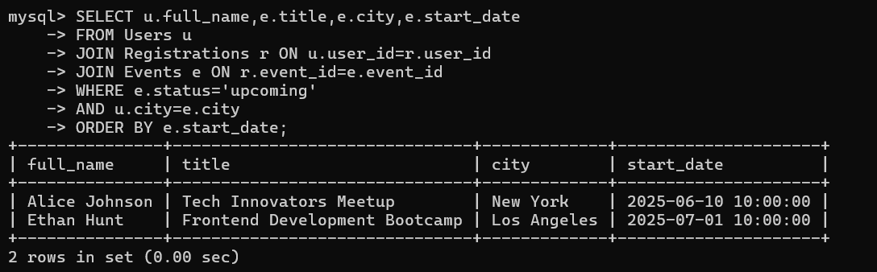
EXERCISE 2
Top Rated Events
SELECT e.title,
AVG(f.rating) AS avg_rating
FROM Events e
JOIN Feedback f ON e.event_id=f.event_id
GROUP BY e.event_id,e.title
HAVING COUNT(f.feedback_id)>=10
ORDER BY avg_rating DESC;
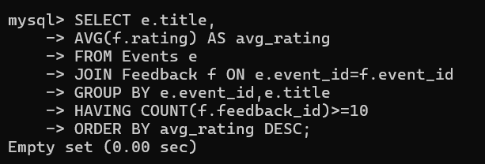
EXERCISE 3
Inactive Users
SELECT *
FROM Users
WHERE user_id NOT IN
(
SELECT DISTINCT user_id
FROM Registrations
WHERE registration_date >= CURDATE()-INTERVAL 90 DAY
);
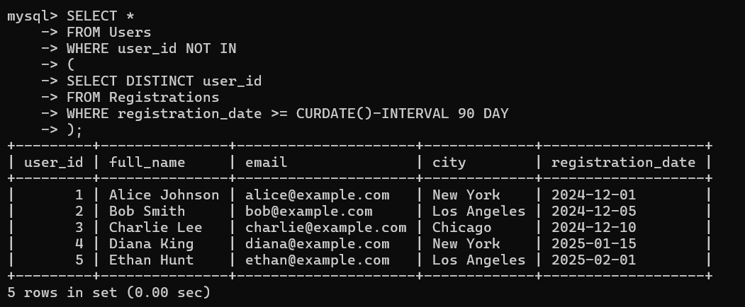
EXERCISE 4
Peak Session Hours
SELECT e.title,
COUNT(s.session_id) AS total_sessions
FROM Events e
LEFT JOIN Sessions s
ON e.event_id=s.event_id
AND TIME(s.start_time) BETWEEN '10:00:00' AND '12:00:00'
GROUP BY e.event_id,e.title;
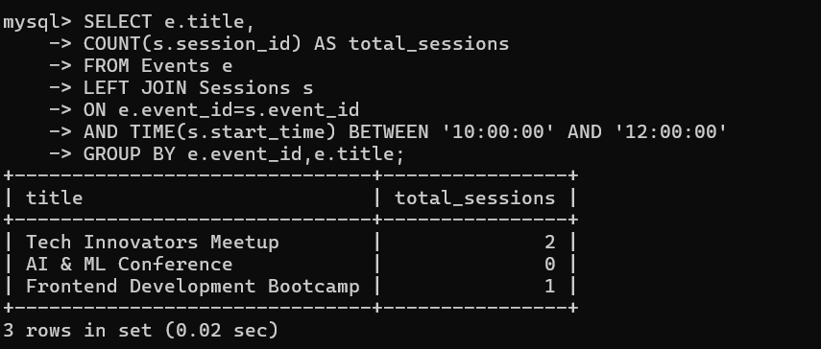
EXERCISE 5
Most Active Cities
SELECT u.city,
COUNT(DISTINCT r.user_id) AS registrations
FROM Users u
JOIN Registrations r
ON u.user_id=r.user_id
GROUP BY u.city
ORDER BY registrations DESC
LIMIT 5;
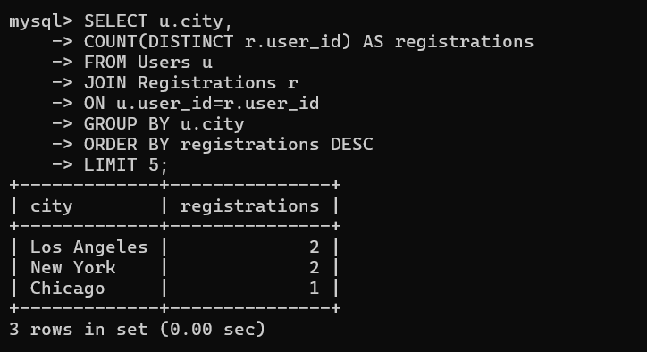

EXERCISE 6
Event Resource Summary
SELECT e.title,
COUNT(r.resource_id) AS resources_count
FROM Events e
LEFT JOIN Resources r
ON e.event_id=r.event_id
GROUP BY e.event_id,e.title;
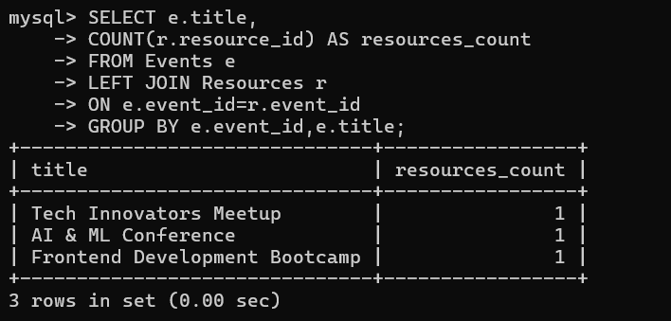
EXERCISE 7
Low Feedback Alerts
SELECT u.full_name,
e.title,
f.rating,
f.comments
FROM Feedback f
JOIN Users u
ON f.user_id=u.user_id
JOIN Events e
ON f.event_id=e.event_id
WHERE f.rating<3;
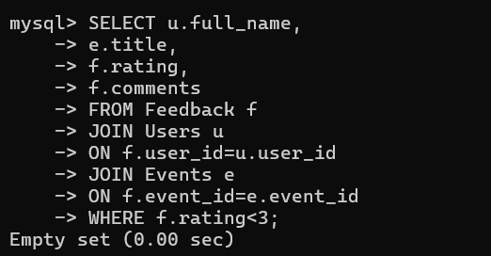
EXERCISE 8
Sessions per Upcoming Event
SELECT e.title,
COUNT(s.session_id) AS total_sessions
FROM Events e
LEFT JOIN Sessions s
ON e.event_id=s.event_id
WHERE e.status='upcoming'
GROUP BY e.event_id,e.title;
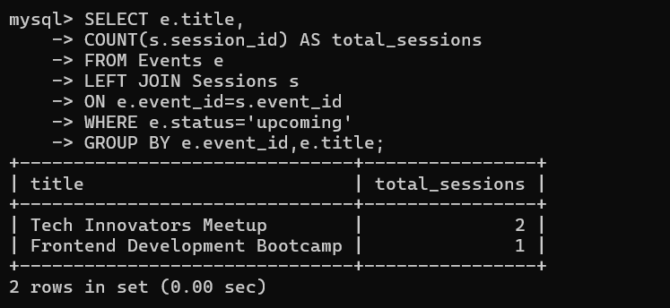
EXERCISE 9
Organizer Event Summary
SELECT u.full_name,
e.status,
COUNT(e.event_id) AS total_events
FROM Users u
JOIN Events e
ON u.user_id=e.organizer_id
GROUP BY u.full_name,e.status;
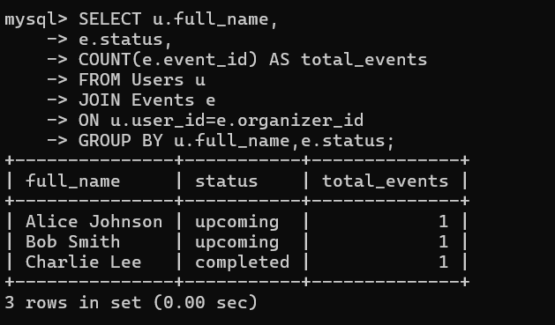
EXERCISE 10
Feedback Gap
SELECT e.title
FROM Events e
JOIN Registrations r
ON e.event_id=r.event_id
LEFT JOIN Feedback f
ON e.event_id=f.event_id
WHERE f.feedback_id IS NULL
GROUP BY e.title;
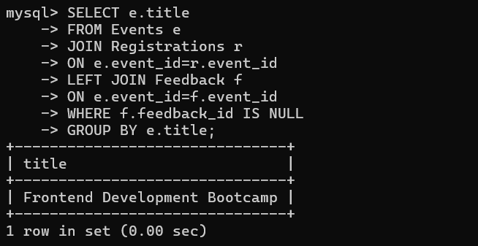
EXERCISE 11
Daily New User Count
SELECT registration_date,
COUNT(*) AS total_users
FROM Users
WHERE registration_date >= CURDATE()-INTERVAL 7 DAY
GROUP BY registration_date;
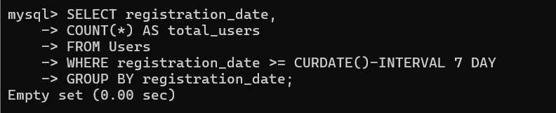

EXERCISE 12
Event with Maximum Sessions
SELECT e.title,
COUNT(s.session_id) AS total_sessions
FROM Events e
JOIN Sessions s
ON e.event_id=s.event_id
GROUP BY e.event_id,e.title
HAVING COUNT(s.session_id)=
(
SELECT MAX(session_count)
FROM
(
SELECT COUNT(*) session_count
FROM Sessions
GROUP BY event_id
) t
);
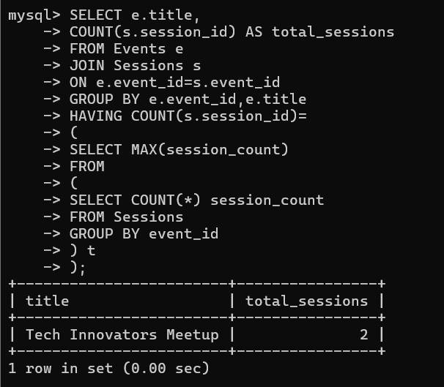
EXERCISE 13
Average Rating per City
SELECT e.city,
AVG(f.rating) AS avg_rating
FROM Events e
JOIN Feedback f
ON e.event_id=f.event_id
GROUP BY e.city;
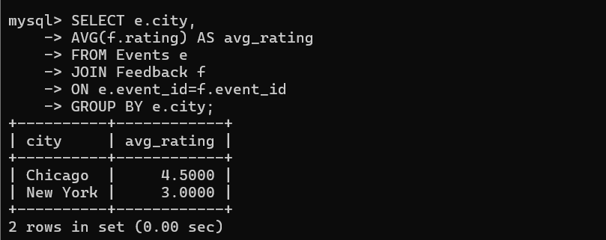
EXERCISE 14
Most Registered Events
SELECT e.title,
COUNT(r.registration_id) AS registrations
FROM Events e
JOIN Registrations r
ON e.event_id=r.event_id
GROUP BY e.event_id,e.title
ORDER BY registrations DESC
LIMIT 3;
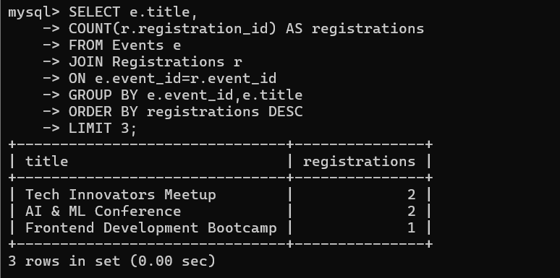
EXERCISE 15
Event Session Time Conflict
SELECT
s1.event_id,
s1.title,
s2.title
FROM Sessions s1
JOIN Sessions s2
ON s1.event_id=s2.event_id
AND s1.session_id<s2.session_id
AND s1.start_time<s2.end_time
AND s1.end_time>s2.start_time;
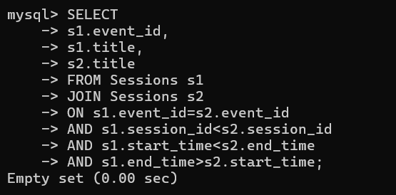
EXERCISE 16
Unregistered Active Users
SELECT *
FROM Users
WHERE registration_date >= CURDATE()-INTERVAL 30 DAY
AND user_id NOT IN
(
SELECT user_id
FROM Registrations
);
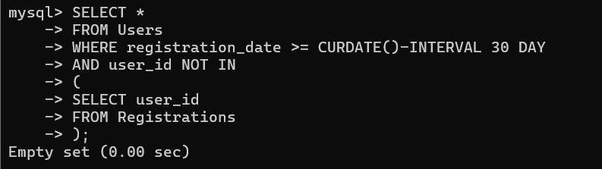

EXERCISE 17
Multi-Session Speakers
SELECT speaker_name,
COUNT(*) AS total_sessions
FROM Sessions
GROUP BY speaker_name
HAVING COUNT(*)>1;
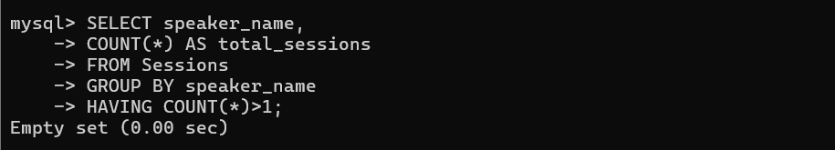
EXERCISE 18
Resource Availability Check
SELECT e.title
FROM Events e
LEFT JOIN Resources r
ON e.event_id=r.event_id
WHERE r.resource_id IS NULL;
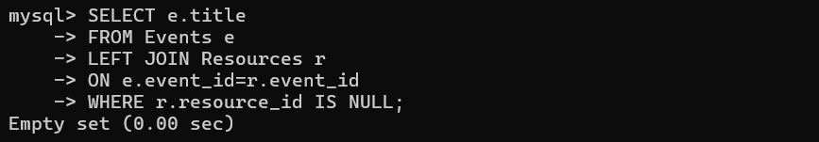
EXERCISE 19
Completed Events with Feedback Summary
SELECT e.title,
COUNT(DISTINCT r.registration_id) AS registrations,
AVG(f.rating) AS avg_rating
FROM Events e
LEFT JOIN Registrations r
ON e.event_id=r.event_id
LEFT JOIN Feedback f
ON e.event_id=f.event_id
WHERE e.status='completed'
GROUP BY e.event_id,e.title;
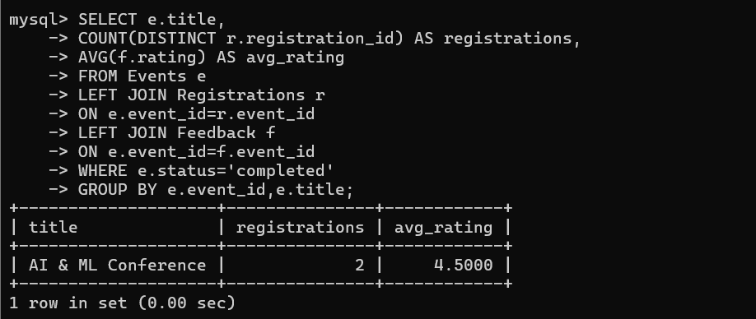
EXERCISE 20
User Engagement Index
SELECT u.full_name,
COUNT(DISTINCT r.event_id) AS events_attended,
COUNT(DISTINCT f.feedback_id) AS feedbacks_submitted
FROM Users u
LEFT JOIN Registrations r
ON u.user_id=r.user_id
LEFT JOIN Feedback f
ON u.user_id=f.user_id
GROUP BY u.user_id,u.full_name;
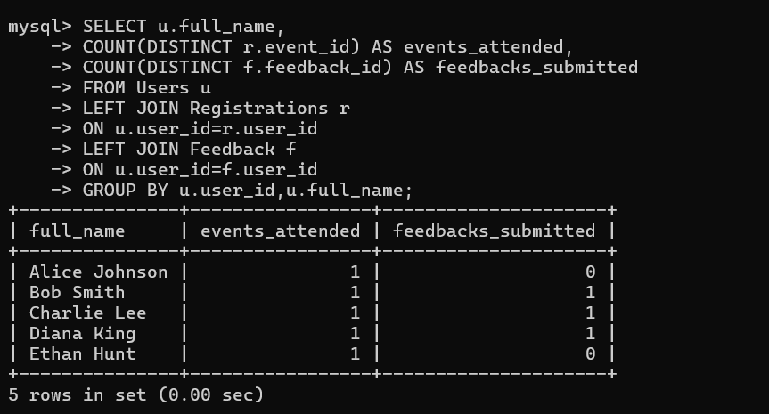

EXERCISE 21
Top Feedback Providers
SELECT u.full_name,
COUNT(f.feedback_id) AS feedback_count
FROM Users u
JOIN Feedback f
ON u.user_id=f.user_id
GROUP BY u.user_id,u.full_name
ORDER BY feedback_count DESC
LIMIT 5;
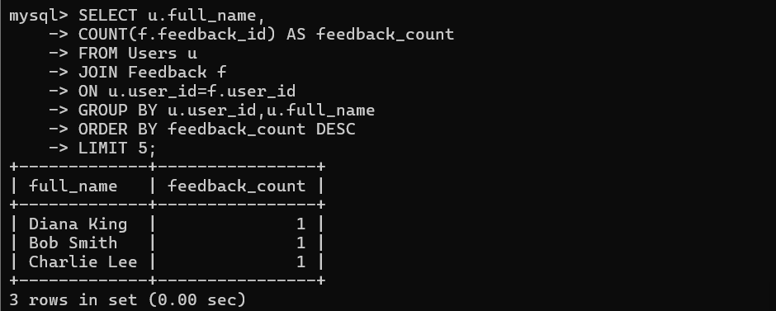
EXERCISE 22
Duplicate Registrations Check
SELECT user_id,
event_id,
COUNT(*) AS duplicate_count
FROM Registrations
GROUP BY user_id,event_id
HAVING COUNT(*)>1;
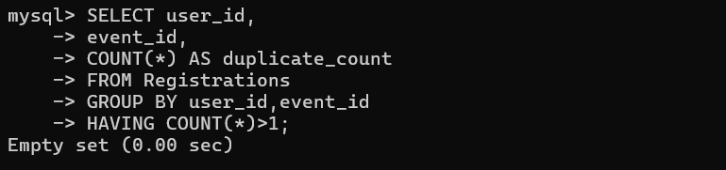

EXERCISE 23
Registration Trends
SELECT
DATE_FORMAT(registration_date,'%Y-%m') AS month,
COUNT(*) AS registrations
FROM Registrations
WHERE registration_date >= CURDATE()-INTERVAL 12 MONTH
GROUP BY month
ORDER BY month;
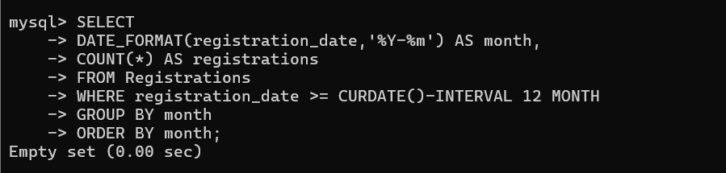
EXERCISE 24
Average Session Duration per Event
SELECT e.title,
AVG(
TIMESTAMPDIFF
(
MINUTE,
s.start_time,
s.end_time
)
) AS avg_duration
FROM Events e
JOIN Sessions s
ON e.event_id=s.event_id
GROUP BY e.event_id,e.title;
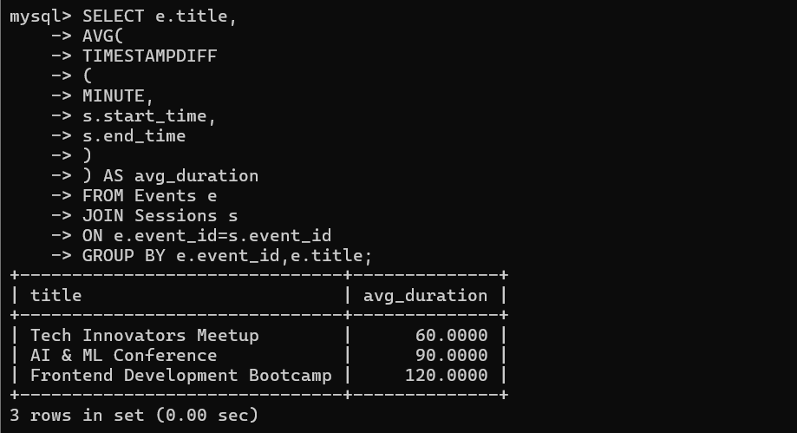
EXERCISE 25
Events Without Sessions
SELECT e.title
FROM Events e
LEFT JOIN Sessions s
ON e.event_id=s.event_id
WHERE s.session_id IS NULL;
